WIX3001 Soft Computing

Tutorial 5: Introduction to Python Programming

There are two approaches for programming in Python.

**Online**: don’t need to install anything. Using Google Colaboratory: <https://colab.research.google.com>. Downside: cannot program if no Internet connection available.

**Offline**: install Anaconda from <https://anaconda.org>. Downside: need to download and install the Python packages.

We’ll start with offline first.

1. Download and install Anaconda.

If you are using an older operating system, make sure you use the appropriate Anaconda version package. Check compatibility here: <https://docs.anaconda.com/free/anaconda/install/old-os/>

1. Start Anaconda Navigator. If using Linux, Anaconda starts by default with Terminal.

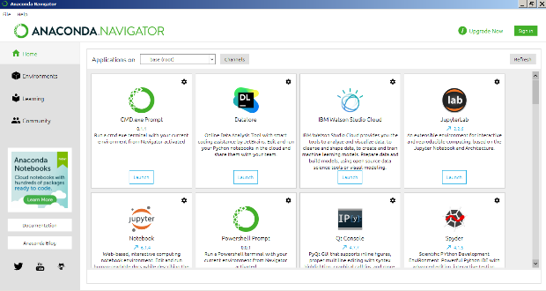

1. Create a new Anaconda environment from the Terminal. For example:

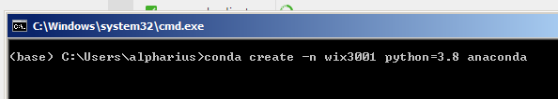

This will create a new environment with the name “wix3001” and installs Python version 3.8 and the Anaconda package.

1. Wait for the installation to finish.

Activate the environment by typing “conda activate wix3001”.

Then start Jupyter Notebook by typing “jupyter-notebook”.

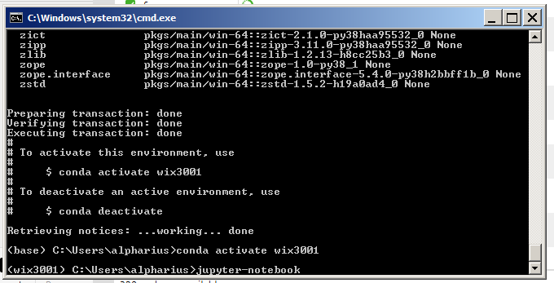

1. Jupyter Notebook will start in your browser. Download “tutorial5.ipynb” from UM Spectrum and load it using Jupyter.

1. Run the first cell by clicking on it and pressing Ctrl-Enter. This will import the Python packages as defined in the cell.

If an error is produced, it means your current Python environment doesn’t have those packages yet. Install it using the Terminal. For example: “pip install tensorflow”

Install all the required packages and try again.

1. The notebook file will record the results for running the codes in each cell.
2. Complete all the exercises in tutorial5.ipynb. Rename the file using your name and submit it via UM Spectrum after completing the tutorial.

**Google Colaboratory**

1. Go to <https://colab.research.google.com> using your Siswamail account.
2. Load the tutorial5.ipynb file from your Google Drive or by uploading it.

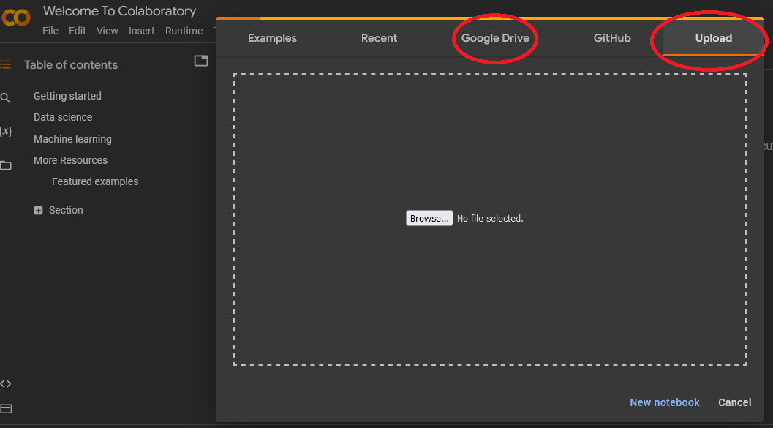

1. You can run each cell again by selecting the cell and pressing Ctrl-Enter.
2. If a specific package is required, then Colab will automatically install it.
3. Complete the exercises in the notebook file, rename the file using your name and submit it via UM Spectrum after completing the tutorial.